Global Grant Opportunities Around the World – Details
Below you will find a lot more information about the Global Grant opportunities we presented in
the November Newsletter. Those who get involved in a Global Grant will find it very rewarding.
to be helping very challenged people in other parts of the world. A club can either be a financial partner where funds are donated only, or the club can be the International Partner if there is not one already committed. An International Partner has much more involvement.

Our District has a Directed Grant to support District 5190 led projects in Sub-Saharan Africa
worth $185,000 and portions can be used to support those projects. Each of these, with the exception of the Senegal project, needs a club to serve as International Sponsor.
If a club chooses to contribute funds to a project whether a Financial Partner or an International
Partner, the District will 100% match their contribution and the District contribution will be
matched by the Rotary Foundation (TRF) at 80%.
If you are interested in any of these projects, talk with your club leadership to get a teamworking
on the process.
If you have questions on these Global Grant Projects, please contact Jon Gresley at
jongresley@hotmail.com.
Table of Contents Click on Title to go to Details
Projects Seeking Funding Now
- Smiles Plus Global Grant
- Guatemala Water Project - Clean Water for the Western Highlands of Guatemala
- Building Climate Resilience of Maya-Achi Communities with Agroecology and Youth Leadership
- Nepal Tuberculosis Treatment
- Reforestation of Bhutan’s Forest
- Project Orales – Young Women Employability Training

Projects Being Developed within District 5190

- Uganda Family Health Days
- Senegal Tree Planting – Fallon Rotary Club
- Uganda Project Search
  - ATTA Breast Milk Bank
  - EMPOWERING DOLWE ISLAND PROJECT (A project to Provide Quality Education and WASH Facilities for Marginalized Children)
  - YOKA ZONE WASH PROJECT CONCEPT – Water Project for Schools
  - Kalasa Community Project – School rehab
  - Water, Sanitation and Hygiene (WASH) & Basic Education and Literacy Project for Kisowera Primary School and the Catchment Community

Projects Seeking Funding now:
Smiles Plus Global Grant
Total Budget – $58,000
Host Club – Trichur Central
Host District – District 3201 (in Kerala India)
International Sponsor – to be defined.
Project description:
Fund 50 surgeries to correct facial deformations performed in 5 hospitals supporting this project
at no cost to client. These surgeries will be performed on both children and adults. All clients
will be from a poor background who cannot afford to get treatment on their own. The clients will
find they have a new lease on life and have more confidence. The surgeries will be performed
in six hospitals that will highly subsidize the cost including the post treatment follow up and
rehabilitation. Normal cost would be $4000 USD and the hospitals will be charging $1150.
Trichur Central will contribute $28,000 USD with District 3201 contribute $10,000 (DDF). They
are looking for an International Partner that would contribute $7000 USD. TRF would then
contribute $13,600 USD. Below are before and after photos of previous patients.

To learn more about this project click here.
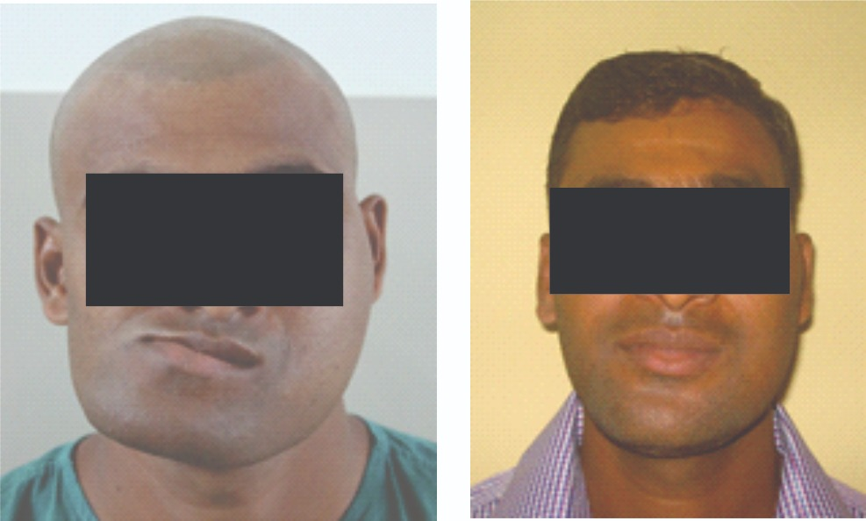

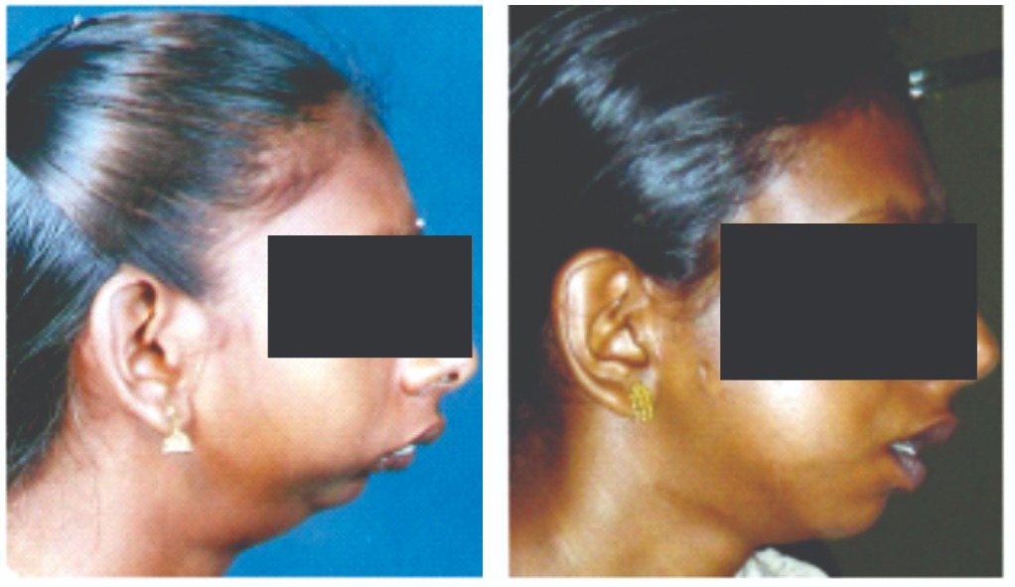

Guatemala Water Project - Clean Water for the Western Highlands of Guatemala
Total Budget – $800,000 (World Vision with fund $400,000 of the total)
Host Club – Rotary Clubs of Guatemala Sur
Host District – District 4250
International Sponsor – Cupertino Rotary Club/District 5170.
Project is joint with World Vision
Project description:
The indigenous people in the Western Highlands of Guatemala have a dire need for clean
water. Women and children fetch less than 5 liters per day by walking 3 – 5 kms at high
altitudes. Much of the water they can get is surface water which is contaminated and leads to
gastrointestinal diseases. Children suffer from severe malnutrition. Guatemala has the highest
rate of stunting in children under 5 years at 42.8% and this is even higher at 58% in the
indigenous population. Being situated in the Central American Dry Corridor, Water scarcity, rain
patterns, and food insecurity catalyze the lack of economic opportunity, human security, and
increases in violence that fuel irregular migration to the United States.

In partnership with World Vision – an RI Strategic Partner, we plan to deliver clean water to 3
communities of about 7,000 people. The project value is $800,000 with World Vision funding
50% of this amount. This project will be the largest Global Grant project that District 5170 has
ever undertaken.
No ambitious project of this scale is ever possible without collaboration and partnerships.
The primary objective of this project is to significantly improve the well-being of indigenous
communities in the Western Highlands of Guatemala by providing consistent,
adequate, and convenient access to clean drinking water. These communities and local
governments will be equipped to facilitate sustainable WASH interventions and services. The
Rotary Club of Cupertino in partnership with the Rotary Clubs of Guatemala Sur,
Quetzaltenango, Los Altos Quetzaltenango & Huehuetenango and World Vision Guatemala is
pleased to implement this large-scale WASH project. This WASH project will use lessons
learned in the WinS (WASH in schools) project successfully completed in Guatemala by the
Host club as well as from World Vision's experience and expertise. The project will bring water
directly to over 7300 people in 3 communities, 9 schools, 3 Health Care Facilities and 13
churches. Without clean or safe drinking water, basic sanitation, and healthy hygiene behaviors,
in homes, schools and health units, sustainable human development is seriously hampered.

Facilitating universal and equitable access to safe and affordable drinking water; Improving
water quality by protecting and maintaining surface- and groundwater resources, reducing.
pollution and contaminants, and promoting wastewater reuse; Facilitating universal and
equitable access to improved sanitation and waste management services in order to achieve.
open defecation-free communities; Improving community hygiene knowledge, behaviors, and
practices that help prevent the spread of disease.

To learn more about this project click here.

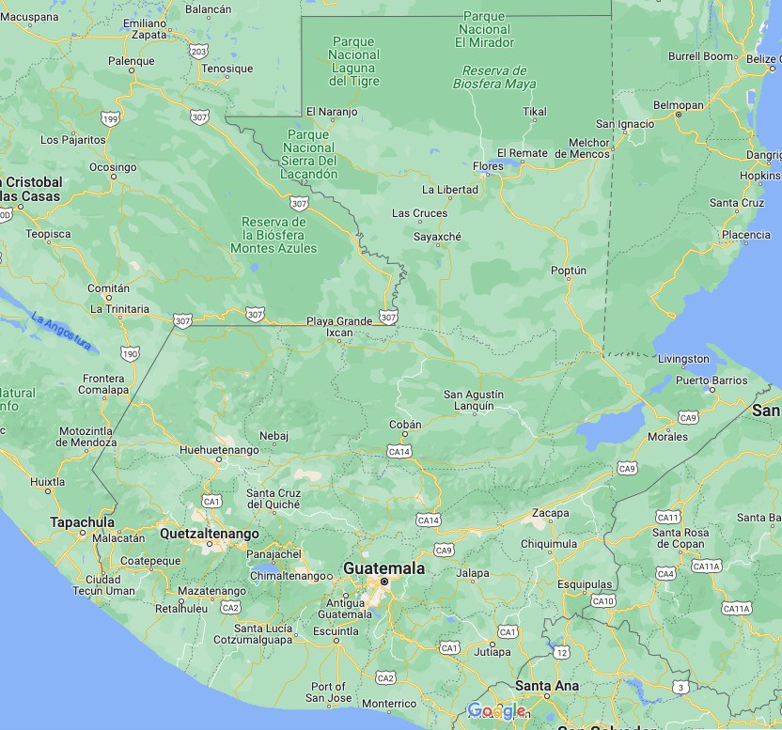
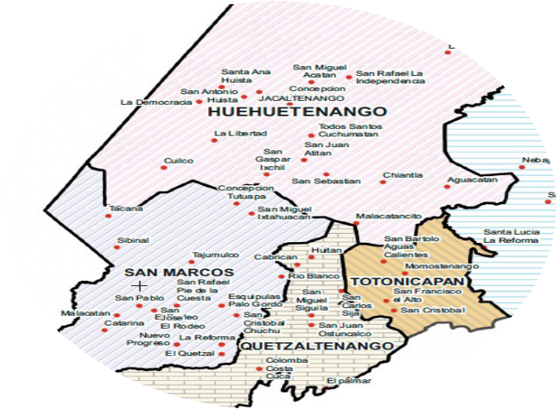
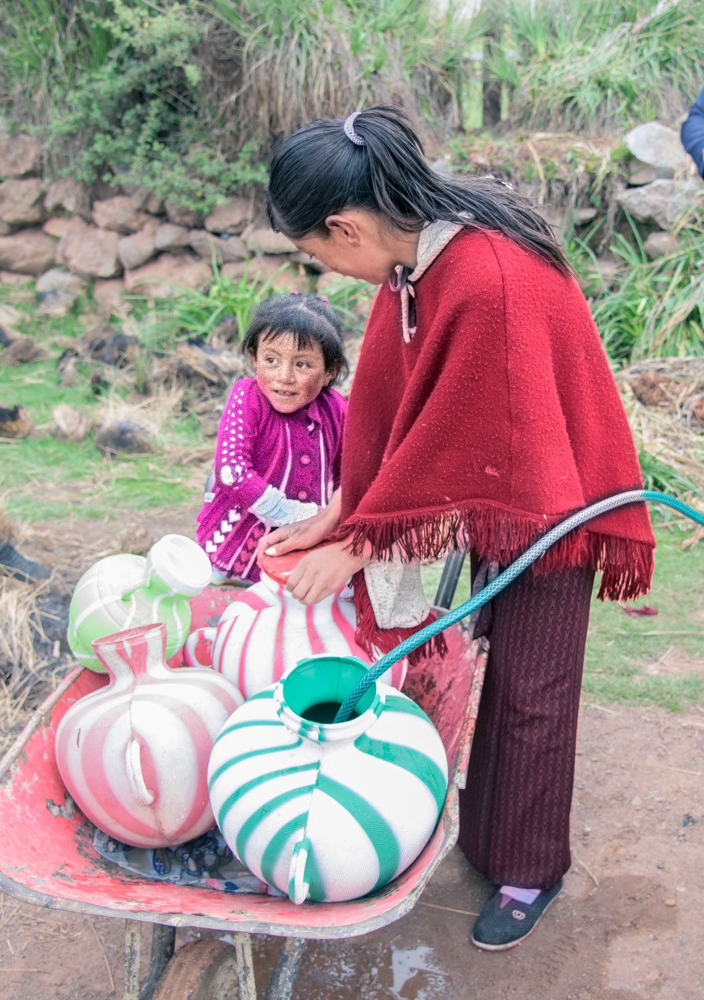

Building Climate Resilience of Maya-Achi Communities with Agroecology and Youth Leadership
Total Budget – $247,000
Host Club – Rotary Clubs of Guatemala Sur
Host District – District 4250
International Sponsor – Oakland/District 5170.
Project description:
Located in the dry corridor of Central America, one of the world’s ten most vulnerable
regions to climate change, Rabinal is an indigenous Maya-Achi area composed of dozens
of communities. In recent years, prolonged droughts attributable to climate change have
caused these subsistence farmers to lose as much as 80% of their crop, causing hunger,
malnutrition, economic hardship, and migration. Under the leadership of trained, local youth
agricultural technicians, this project will promote both traditional and modern, culturally
appropriate, low-cost, sustainable farming techniques to strengthen climate change resilience
among 375 families in ten communities. Two previous global grants (2021-2023) have
established the effectiveness of many key strategies and provide guidance for new ones.
These strategies are based in agroecology—using ecological principles and practices in
farming to reduce costs, improve sustainability, and enhance long-term productivity. Key
strategies of the project include:
• Reforestation, which improves nutrition; provides shade for people, coffee, and other crops; reduces temperature, stabilizes soils, and improves soil water retention. Thousands of fruit and forest trees will be planted
● Animal Vaccination, which improves the survival of poultry from 50% to 90%, a huge nutritional and economic benefit from a $0.10 investment per bird.
● Crop Diversification, which provides marketable products that are more resistant to drought while improving nutrition.
● Vegetable Gardens and Greenhouses, built with local materials and labor, which provide a high humidity, more productive space to grow a greater variety of vegetables, protected from insects.
● Water Conservation & Drip Irrigation, which can irrigate many more plants with much less water.
● Soil Management, which helps retain nutrient rich top soil through training in everything from
contouring to organic supplementation.
● Native Seed Exchange, which maintains genetic diversity and culturally important varieties while minimizing the need for and expense of GMO seeds, and toxic agrochemicals, such as glyphosate (RoundUp)
Adapting to a crisis is hard and takes time. People need to see, concretely, how changes can
improve their future. Two to three Model Plots in each of 10 communities, as proposed by our
agricultural technicians, are incorporated in the project. In addition to all the techniques
described above, the plot owners—mostly women—will be trained to diversify their production,
utilizing integrated agroecology, and sophisticated irrigation systems. They will also be trained to
produce fertilizer, soil amendments and pest control products organically, both for their own use
and sale. The intended result is less individual and community investment in chemical fertilizers
and insecticides, improved soil and human health, and reduced environmental damage. Local
farmers will be invited to view these plots to see the benefits and will be encouraged and
assisted in incorporating the techniques on their own farms.

These lines of work will be carried out by the grant’s cooperating partner, Voces y Manos,
which, under prior global grants, has trained a team of Maya-Achí, young-adult, agricultural
technicians. As native speakers of the Mayan language, they have a deep understanding of the
community context and have built exceptional trust in the communities where they work.
Regular financial oversight is provided by both Rotary clubs and Rotary Foundation.
Anticipated outcomes of the project:
★ Scale up training in sustainable agricultural practices to 375 farming families (1,875 people) across 10 communities by increasing agricultural technician staff.
★ Increased use of organic inputs and reduced use of toxic agrochemicals
★ Improved income, resilience to climate change, quality of life, and sustainable productivity by training in the practices shown to be effective in prior projects
★ Strengthened nutrition of households through more diversified food production from vegetable gardens and greenhouses
★ Multiple plots demonstrate to the community and region the benefits of a more sustainable agroecological approach to subsistence farming

To learn more about this project click here.
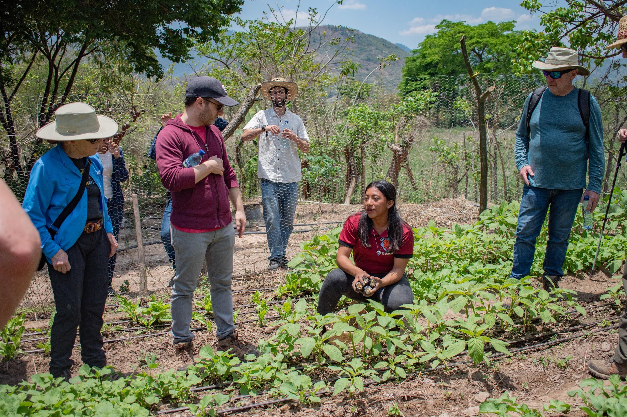
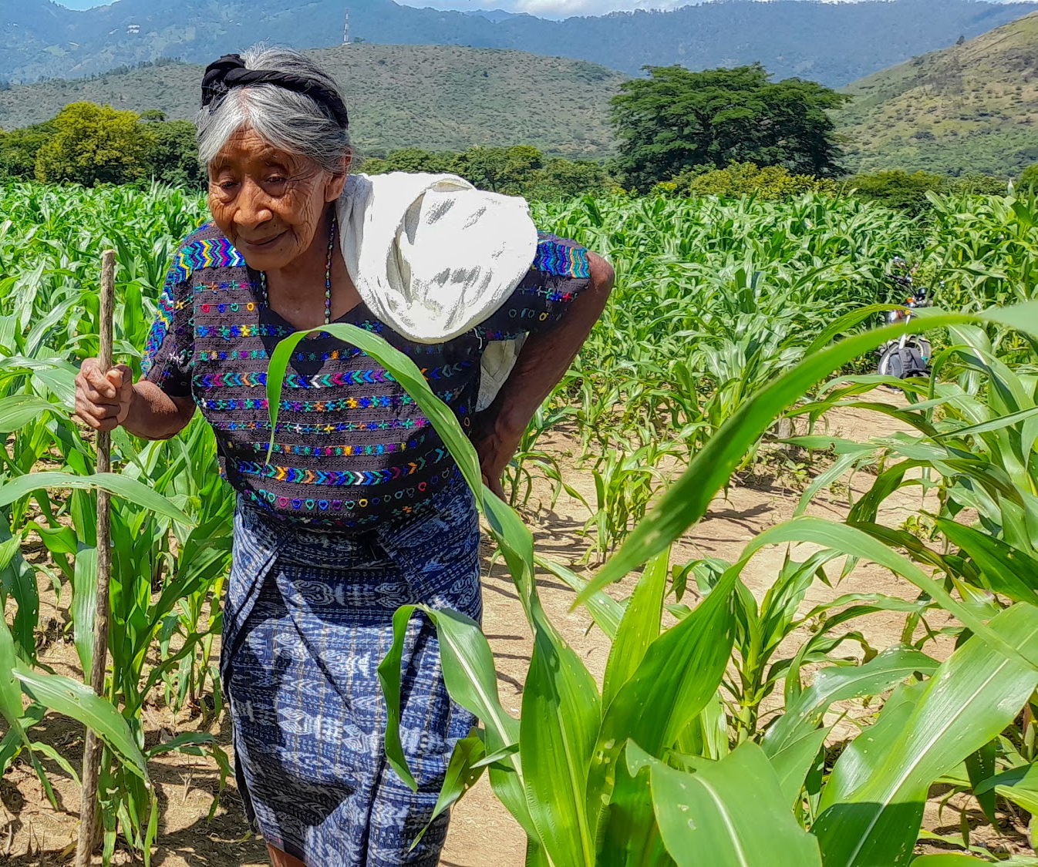

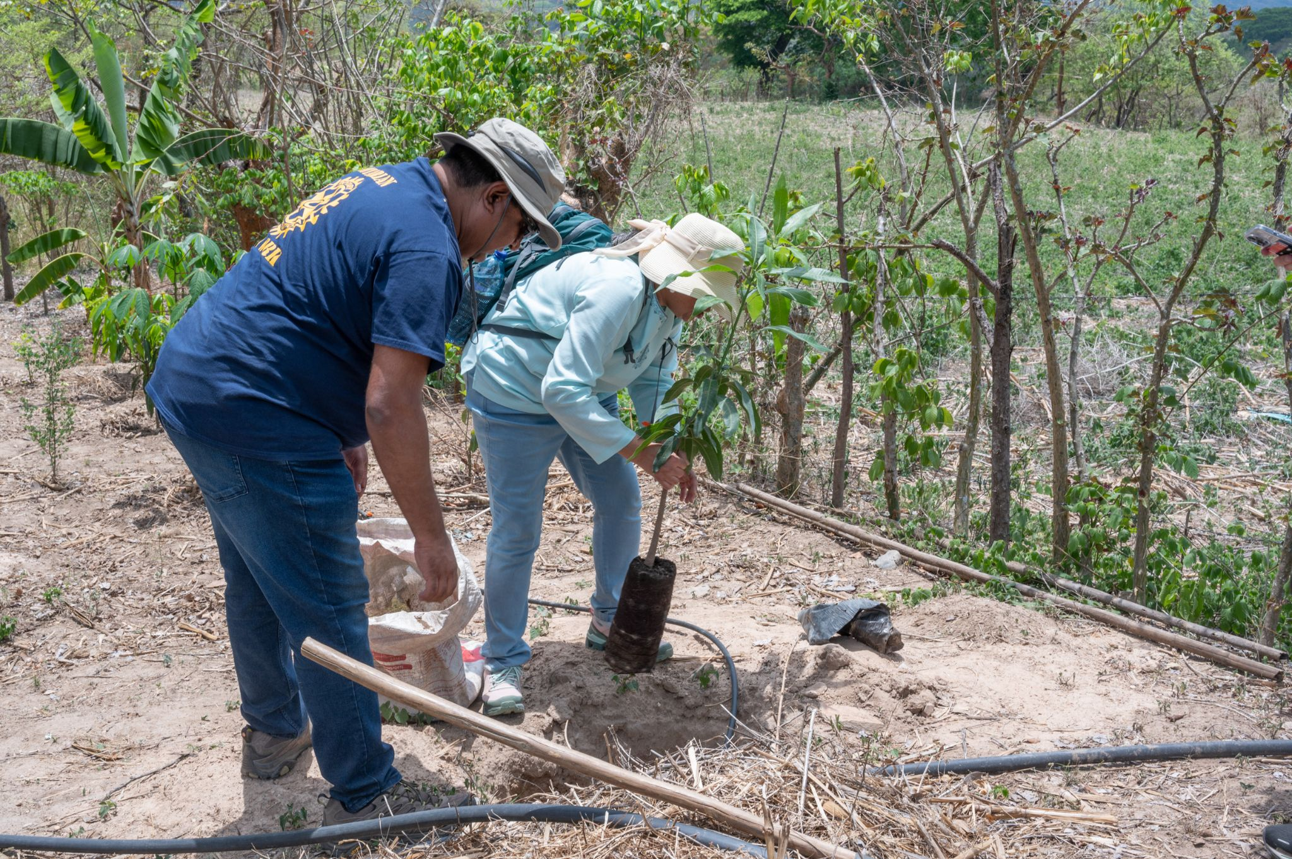

Nepal Tuberculosis Treatment

Total Budget – $300,000
Host Club - Kathmandu-Midtown
Host District – 3290
International Sponsor – Salt Lake City/District 5420
Project description:
Tuberculosis (TB) is a preventable and curable infectious disease, and yet it still causes 10
million cases and 1.5 million deaths globally every year. The majority of these cases are in the
poorest communities of the poorest countries. Sadly, poverty fuels TB and TB fuels poverty.
Nepal is one of the world's least develop countries and has a high burden of TB.

The Prevent TB to END TB will implement a new shorter treatment for TB preventive therapy
known as the 3HP regimen, in Nepal. This will enable people who have been in contact with an
infectious TB case to receive this simple treatment which will prevent them becoming sick with
TB disease. By eradicating the bacteria which causes TB from their bodies before they become
sick with TB, we will also protect their families and the wider community from infection with the
bacteria and prevent the long-term social and economic consequences of TB in the family and
wider community.

The project will also engage in advocacy for scale-up of TB preventive therapy
and train 100 healthcare workers in protocols and counselling for safe and effective delivery of
TB preventive therapy.

Tuberculosis is a very common disease in Nepal, despite being preventable and curable. Every
year there are 70,000 TB cases and 17,000 Nepalis die of TB. While there is a national
government TB program for identifying and treating TB cases, this program does not have the
funding to provide TB preventive treatment to adults who are living in a household with a TB
case. While a new, shorter preventive TB treatment is available, and is strongly endorsed and
recommended by the World Health Organization, it has not been made available for adults in
Nepal.

Communities affected by TB in Nepal are eager to have access to this treatment which can
prevent people from falling sick with TB, and prevents the devastating long-term socio-economic
consequences of TB for the family and wider community. TB affects the poorest and most
vulnerable members of communities and can often precipitate a family into extreme poverty
through loss of subsistence income, usurious loans, or sale of income-generating assets like a
buffalo. This leads to severe long-term consequences such as children withdrawn early from
school, loss of shelter, food insecurity, child marriage or vulnerability to human trafficking.

This project will provide testing for TB infection to contacts of TB cases and support those
infected with the TB bacteria but not yet sick with TB disease to complete TB preventive therapy
using the 3HP treatment regimen. This treatment consists of two drugs (rifapentine and
isoniazid) taken once a week for 12 weeks. It is safe and highly effective at preventing
progression to active TB disease. We will follow World Health Organization (WHO) guidelines
for the evaluation and treatment of people exposed to TB infection. the project will provide
training for healthcare workers in safe and effective delivery of TB preventive therapy.

The project will be implemented in two districts of Nepal-Pyuthan and Chitwan districts in close
integration with the government TB program services.

To learn more about this project click here.

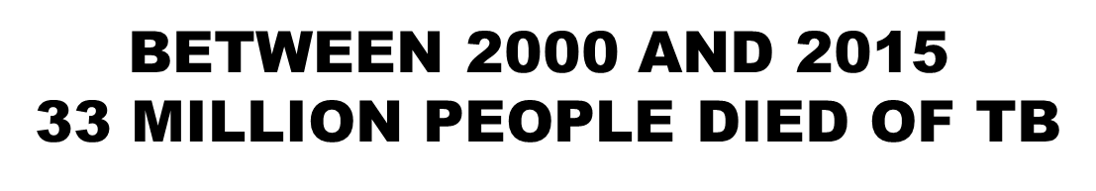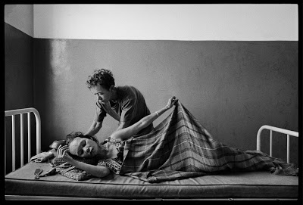

9 million people in Nepal are latently infected with TB bacteria Undiagnosed cases continue spreading TB but they can be PREVENTED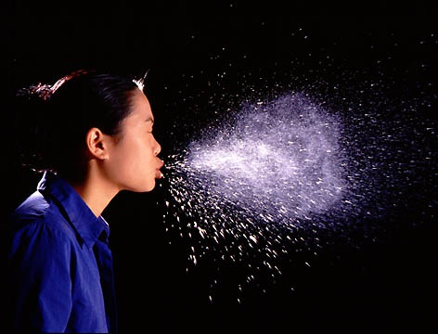
Undiagnosed cases continue spreading TB but they can be PREVENTED

Reforestation of Bhutan’s Forest
Total Budget – $87,300
Host Club – Rotary Club of Thimphu
Host District – 3292
International Sponsor – E-Club of World Peace/ District 5330
Project description:
Reforestation of Bhutan's forest Project is intended to restore the forest through restocking of
its forests where the forest cover that has been at high risk of depletion due to increased
development activities. For the benefit of the environment and the human population and
wildlife, Bhutan has made a Constitutional commitment to always maintain 60% forest cover.
Such a commitment puts a heavy burden on the country and its population's livelihood .
However, Bhutan is committed to uphold its promise to ensure that the environment, human
and the animal species remain and are protected.

A project titled Bhutan Forest Restoration (BFR) in collaboration with the Royal Government of
Bhutan is initiating a tree planting project to repopulate a forest area measuring 100 acres, at a
location called Kuenselphodrang in Thimphu, Western Bhutan. Under the initiative, a total of
50,000 tree saplings will be planted. The tree species chosen for planting are blue pine,
chirpine, rhododendron, dogwood, oak , cherry and peach. The human residents, animals in
the forests and the local environment will be the beneficiaries of this global grant. With the tree
planting there will be increased offset of carbon to help reduce air emissions.
Project once funded and approved to be completed by June 30, 2024

Department of Forest and Park Services will provide technical and supporting help to the
project.

The Rotary Club of Thimphu as the Host Club will oversee the implementation of the Project
including procurement of the project supplies. The Club will ensure that the project is started
and completed on time and within the budgeted amount. The Club officials will carry out
periodic inspections of work progress so that quality work is done.
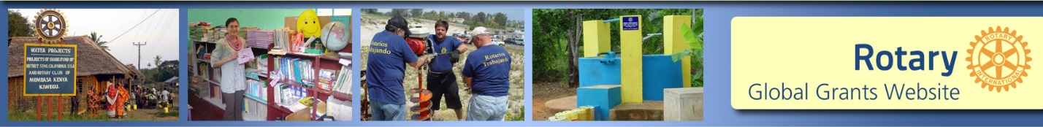

Project Orales
Total Budget – $50,000
Host Club – Rotary Club Tijuana Oeste
Host District – 4100
International Sponsor – Nevada City 49er Breakfast/ District 5190
Project description:
Train Young Women
Following recruitment, an eight-week training workshop (5 days per week, 4 hours a day) is delivered to the young women, it includes:
• Employability Life skills, for example: personal strengths and weakness analysis, responsibility, teamwork, time management, communication, public speaking, critical thinking skills, development of a personal career plan, and others.
• Job seeking skills, including guidance in job search and interviewing techniques, support in developing resumes and cover letters and site visits to employers and training institutes
• Basic IT skills
• Customer care service
• Vocational Orientation;
• Sexual and Reproductive Health information
• Personal Hygiene and Professional Presentation
• Medical services, distribution of contraceptives
• Nutrition
• Leadership development
• Drug addiction prevention
• Dance and corporal expression
• Psychological counseling
• Entrepreneurship
• Community Activities
As per the pilot project, the training is carried out in a highly interactive and personalized
fashion. The modules are designed around engaging activities that encourage self-reflection,
group work and practice of skills learned. The team of facilitators, counselors and mentors
serve as a strong support for each young person. Training culminates in a graduation ceremony
attended by the young women, their families, and key stakeholders from the city, to encourage
the graduates to pursue their plans developed in the workshop. Young women receive
certificates that document their successful completion of the training.

Provide Job Placement.
While the young women are still in the training workshop, the counselors scope the local job
market research and source potential job opportunities that match the young women
beneficiaries' skills and interests. Given the limited educational attainment of the young women
beneficiaries, decent entry-level positions, with some growth potential and benefits will be
targeted. Initial market research indicates several potential sectors with these types of jobs,
including commerce, tourism, restaurants, maquiladora assembly plants, among others. Some
types of jobs that are expected to be secured are receptionists, waiters, kitchen assistants,
machinery operators, secretaries, and sales clerks.

Upon graduation, young women will begin to receive four months of personalized job placement
guidance and support from their assigned counselor. Young women are introduced to local
employers through a job fair as well as through direct connections to job opportunities that the
counselors have identified. Counselors also organize ‘employment clubs’ to bring together
young women not yet placed to provide guidance and allow for them to share information and
encouragement. Over the four months, the counselors help the young people prepare for their
interviews and follow up with them to provide mentoring and advice after they have been placed
in jobs.

To learn more click here.

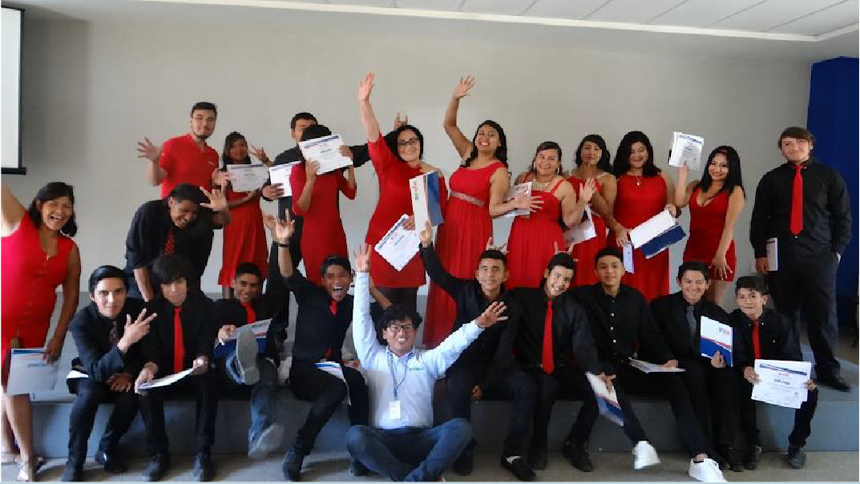

Projects being developed within District 5190

Uganda Family Health Days
Host Club – No club selected yet
Total Budget -
International Sponsor –
Project Description:
Since 2012, Rotary Clubs in Uganda have sponsored free health camps for people in poverty in areas that are hard for the medical system to reach. The health camps provide screening (testing) for malaria, hypertension, diabetes, HIV/AIDS, Covid, cervical cancer, vision, hearing, and dental. Treatments include de-worming, safe male circumcision, medicines, vaccinations, tooth extraction and referrals to healthcare centers and hospitals. The expectation is to sponsor 70 sites, and serve more than 35,000 people of poverty. 2024 continues to be a critical year for Rotary Family Health Days because of the 2-year Covid lockdown, critical va has caused vaccination to be at a dangerously low level--especially for people in hard-to-reach areas. Further, rumors are circulating that vaccines are not safe. We will work with faith leaders to squelch these rumors.
Uganda Rotary Family Health Days (RFHDs) implements a monitoring and evaluation system that not only assesses user and sponsor satisfaction, it measures sustainable outcomes, e.g., behavioral changes in personal healthcare.

To learn more click here.

Senegal Tree Planting – Fallon Rotary Club
Project will build on the club’s District Grant last year where they worked with an effective NGO
to plant saplings, build nurseries, and educate the populace in Senegal, Africa.
Uganda Project Search
We have requested project proposals from 10 Ugandan Rotary Clubs active in GGs and
awaiting feedback. We have received 5 proposals which are attached below.

ATTA Breast Milk Bank
Host Club - Kampala South
Total Budget - $49,000
International Sponsor –
Project Description:
Founded in 2021, ATTA Breastmilk Community aims to end newborn death, through breastmilk donation while prioritizing maternal health and mental well-being. It is registered in Uganda as a not-for-profit social enterprise, the Alyssa Marie Foundation, dedicated to supporting parents and healthcare workers to provide the best possible nutritional start for newborns through facilitating the secure donation of breastmilk, training, and community engagement. ATTA has managed to train 500 mothers, onboarded 41 volunteering donor mothers and dispensed 200L of breast milk to a total of 91 Newborns in less than two years of operation.
Breastfeeding is recognized as an important public health issue with enormous social and economic implications. Infants who do not receive breast milk are likely to experience poorer health outcomes than breastfed infants; mothers who do not breastfeed increase their own health risks. In a study that comprised 211/428 (49.3%) males and 217/428 (50.7%) females, majority of whom were second and third born children (155/428; 36.2%) with a birth interval of two or more years (198/281; 70.2%). The infants had a mean age of 3.5±1.56 months. Majority (335, 78.3%) of the mothers lived in male headed households who were mainly their spouses (313/427; 73.6%) and had attained secondary education (264/427; 61.8%). The prevalence of exclusive breastfeeding was 183/428; (42.8%). In total, 131 (30.6%) of the children received pre-lacteal feeds mainly warm water (40.5%) or glucose solution (35.5%). On analysis of the prevalence of EBF by the infants’ age, EBF increased slightly from 85.7% at zero months to 87.2% at one month and then rapidly dropped to its lowest (24.6%) among five months old children. At the time of the study, none of the respondents fed their child expressed breast milk, however 76 (18%) had ever expressed breast milk for their child when critically ill in the past.
Exclusive breastfeeding (EBF) for the first six months of life is effective in preventing infant morbidity and mortality. However, 36% of Ugandan children below 6 months are not breastfed exclusively despite its active promotion.
This project aims to end newborn death, maternal, and mental health challenges through breastmilk donation and facilitating the public awareness and change of behavior. It will initially equip one center with equipment to enable pasteurization and storage of breast milk in a safe environment, enhance healthy collection and dispatch of breast milk and
train mothers to increase breast milk production.
Project Objectives:
The main goal of the project is ending the newborn and maternal deaths due to lack of breast milk and improve mental health in communities that usually comes out of the impact of no breast milk.
The specific objectives include:
- To make equitable access to breast milk to all newborn children irrespective of the statuses of the parents and their inclination.
- To reduce the number of children developing with impaired cognitive functions.
- To improve the community mental health and well-being

In so doing we shall enhance the Maternal and child Health wholistically while catering for their
mental health as well.
To learn more click here.

EMPOWERING DOLWE ISLAND PROJECT (A project to Provide Quality Education and WASH Facilities for Marginalized Children)

Host Club - Rotaract Clubs of Bwebajja
Total Budget - $39,270
International Sponsor –
Project Description:
This inspiring initiative empowers marginalized children on Dolwe Island, situated in the remote reaches of Lake Victoria in Namayingo district, Eastern Uganda. It focuses on expanding access to secondary education and essential Water, Sanitation, and Hygiene (WASH) facilities. This effort aims to address the pressing needs of the island's residents, with a particular focus on children, to pave the way for a brighter future.
Dolwe Island, part of the Bukooli Islands, lies approximately 6 hours away from the mainland, accessible via canoe or ferry. It spans around 25 square kilometers and is home to a population of at least 35,000 residents, with fishing as the primary source of livelihood. Despite its considerable population, Dolwe Island has only five government primary schools and one secondary school- Dolwe Parents Secondary School which was founded in 2021 by the community.
Due to the poverty levels on the island, most children drop out of school in primary and many don’t continue to Secondary level. Only a handful of families are able to send their children to schools on the mainland, widening the educational divide. It is not uncommon to find young girls getting pregnant before their 16th birthday, thereby entering into unplanned marriages. The absence of nearby secondary schools has perpetuated this issue. Recognizing this educational gap, the community established Dolwe Parents Secondary School, currently with two classes, S1 and S2, on a single block. The rest of the classes (S.3 and S.4) could not be introduced due to lack of infrastructure and other educational requirements. The school has a low student population of 80, with 44 boys and 36 girls with 6 teachers (4 male and 2 female).
Problem Statement:
Dolwe Parents Secondary School is facing a critical lack of educational infrastructure which limits its capacity to only two classes. The existing classrooms are in a state of disrepair. In addition, the school also lacks scholastic materials, furniture, among others.
Compounding the above challenges, the school lacks sanitation facilities (toilets), requiring students and staff to travel half a kilometre to a nearby primary school that has toilets. This has resulted in instances of open defecation. This desperate situation has led to unfavourable learning conditions, high illiteracy rates and poor hygiene practices.
There is also increased cases of gender-based violence, early child marriage and rising crime, all of which perpetuate unequal access to resources and perpetuate the cycle of poverty. Annex 1 attached shows the current state of the school.
Proposed Project Interventions:
Whereas there are several critical challenges, this project aims to focus on the following critical areas:
1) Enhance Access to Quality Education: This will be undertaken through putting in place a fully stocked library. This will however require slight expansion and securing of the existing room. The existing classrooms will also be given a better internal finishing before stocking them with desks and other required facilities for learning. The communities will also be sensitised about the benefits of educating children, and the dangers of early marriages. It is worth noting that the Rotary Club of Bwebajja plans has commenced efforts to extend the existing classroom block to accommodate two extra classrooms for S.3 and S.4. However, this scope of work is a separate project, and not considered as part of this project.
2) Improve Sanitation and Hygiene Facilities: This will be addressed through provision of WASH facilities at the school including water harvesting systems and toilet facilities. These pit latrines will be specifically designed to accommodate the expected low water table in the area.

To learn more click here.

YOKA ZONE WASH PROJECT CONCEPT

Host Club - Rotary Club of Kisugu - Victoria view
Total Budget - $30,724
International Sponsor –
Project Description:
Rakai District experiences dry seasons for most part of the year. The Government sponsored schools for the orphaned and vulnerable children in Rakai are not connected to the main water supply and do not have any source of water supply. These are around 10-20 schools, and their guardians are categorized as extremely poor who cannot afford to pay for water. There is a short window of relief which spans less than 4 months annually, where water can be collected from gutters. However, for the rest of the year, women and children are forced to wake up by 3 or 4 am to walk up to trek 10 kilometers to find a water spring.
This is double work for students who have to fetch water both for home and school consumption. The implications are that students i) do not have time to study ii) girls are often raped iii) girls end up entering early marriages as they can’t cope with water shortages and education.
The other detrimental problem is that the springs are not built or protected from contamination. According to the assistant chief administrative Officer in Rakai district 68% of the people in Rakai are exposed to contaminated water. This has led to rampant waterborne diseases such as dysentery, diarrhea and bilharzia which have continued to claim lives of people, especially the young. A study in 2016 had 267 children less than five years old with acute diarrhea admitted to Rakai General Hospital in a period of three months. This water shortage challenge was worsened by COVID 19 pandemic.
- Project Objectives
  - Improve the accessibility of safe water to the 10 needy schools and therefore improving health and quality of life of the students.
- To establish a safe water source for easy access, availability and sustainable management of water for the school communities for day to day use especially during dry season.
- To improve on menstrual hygiene management in schools and keep girls in school.
- To help homes of old men and women near the school communities with safe and clean water for drinking especially in dry season.

- Project Beneficiaries:
  - 6500 students through improved access to safe water
  - 100 households close to the schools.

- Project Activities
  - Water
    - Community education and safe water use promotion in the school.
    - Creating of water user committees
    - Installation of water tanks for water harvesting

- Expected results
  - Improved performance of the students in school
  - Improved health and hygiene amongst the students
To learn more about this project click here.
Kalasa Community Project

Host Club - Rotary Club of Sunrise Kampala
Total Budget - $76,889
International Sponsor –
Project Description:

The school and the entire community lack sources of safe water and adequate sanitation facilities. The school dormitories are dilapidated, the washrooms area disaster, the kitchen is not worthy the name and all these compromise the children’s health and ability to learn. Notwithstanding, enrollment has risen to 840 students and is still growing. The only Rotary provided borehole broke down a couple of years ago and although remedial works was attempted it is sub-standard. Further, the borehole is serving more people than it should while the only other source of water is a private dam 3km away from the school which is shared between animals, the school and the community. It is not maintained in anyway and is a health hazard.

Proposed Activities:
• Construction of three (3) new VIP pit latrines with associated sanitation amenities
• Construction of washrooms for boarders, for both girls and boys and teachers with proper drainage and waste water disposal
• Installation of one 10,000lt. plastic water tank complete with rainwater harvesting fixtures
• Procurement of 50 wooden desks
• Repair and upgrading of existing latrines and water systems
• Training to improve hygiene and sanitation knowledge of teachers, pupils and the community

Expected Results:
• Access to better sanitation facilities and safe drinking water by pupils, teachers and the community
• Improved attendance and retention among girls; and children with disabilities
• Improved literacy and academic performance by pupils in supported school
• Improved sanitation and hygiene knowledge by the teachers, pupils and the community

To learn more click here.

WATER, SANITATION AND HYGIENE (WASH) & BASIC EDUCATION AND LITERACY PROJECT FOR KISOWERA PRIMARY SCHOOL AND THE CATCHMENT COMMUNITY

Host Club - Rotary Club of Kampala - Ssese Islands

Total Budget - $42,639
International Sponsor –
Project Description:
How the Project will address the Identified Needs:
Three new segregated VIP pit latrines, two for Kisowera Primary School (one each for boys and girls), and one for St. Stephen Church of Uganda will be constructed. The boys’ wing will have six (6) stances (one dedicated to disabled children) and a urinal, while the girls’ wing will have six (6) stances (one for children with disabilities), a separate room for hygiene and menstrual management and waste covered bins for disposal of sanitary pads. The stances for disabled children will be fitted with disability-friendly accessories. Handwashing stations will also be provided close to each latrine to promote hand-washing practices.

The school will also receive one 10,000lt. plastic water tank complete with rainwater harvesting accessories to improve availability of and access to water by pupils and staff. The missing fittings on existing latrines and water systems will also be replaced. Additionally, hygiene and sanitation education including training in making of reusable sanitary pads – to empower adolescent girls and women with knowledge and skills to manage their menstrual hygiene in a sustainable way - will be part of the wider context of health education in the school and the catchment community. The school will also receive 50 new wooden desks to supplement the existing stock.

To learn more click here.

Uganda Tuberculosis –
This grant will leverage what is learned from the Nepal Tuberculosis Grant. Work is currently defining the viability of this project.

