International Service: Many High-Impact Projects in 2021-2022

Despite the restrictions caused by the Covid-19 pandemic worldwide, many of our clubs have been quite active with international service projects this year. Read all about them here!
============================================================================

The Rotary Club of Incline Village has been busy with a few projects in conjunction with the Rotaract Club of Kerrogie, in Addis Ababa, Ethiopia. They organized a mask manufacturing project with a small grant in the months following the start of the COVID pandemic. Together they distributed school supplies to underserved students and supplied hundreds of washable sanitary products to girls and young women to help them attend school regularly. Then, in 2021-2022 with a $5000 donation from Incline Village, Tahoe Incline and Tahoe City clubs, they also gave school supplies benefitting hearing and impaired students and more washable sanitary supplies benefitting over 450 young women this Spring. Fantastic results despite severe economic pressure, a global pandemic and horrific civil war.

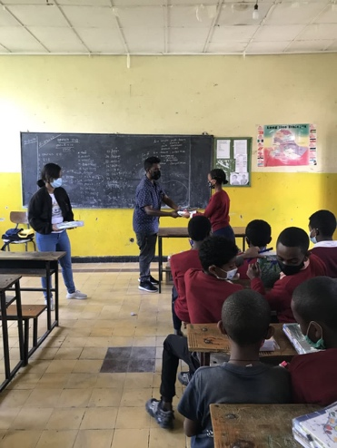
School in Addis Ababa, Ethiopia with donated supplies

The Tahoe-Incline Rotary Club has been active with their medical equipment project in Nepal. They made a $3200 contribution to the Rotary Club of Kathmandu Mid-Town which financed medical equipment and supplies to treat COVID-19 cases for six public health posts serving poor populations in the Khotang District of Eastern Nepal. These included an oxygen concentrator, test kits, surgical masks, a sanitizer and transport costs. Another organization was authorized to distribute the supplies this past March. Club members have also donated to Ukraine refugees through RI Doctors without Borders and World Central Kitchen.

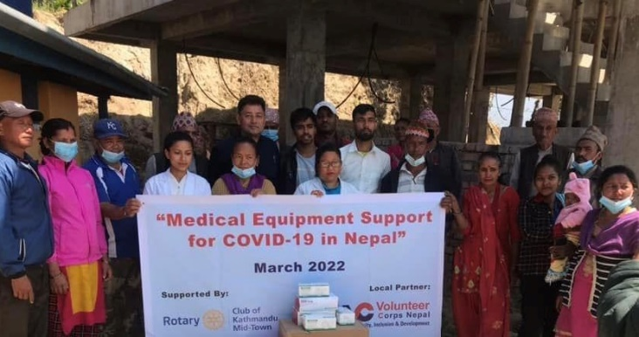

Rotary Club of Kathmandu Mid-Town with outlying clubs in Nepal
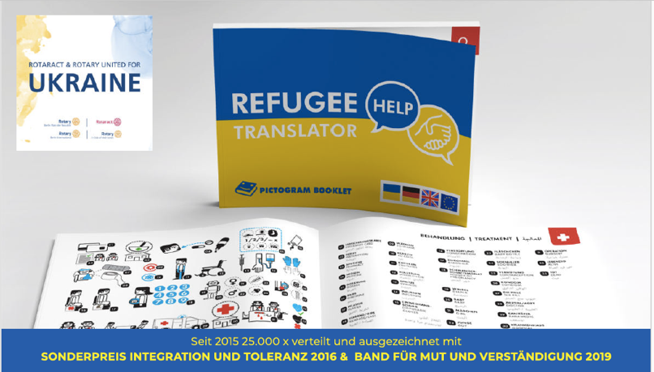
English language materials

The Rotary Club of Reno Central has funded many global projects. Several are for clean water and sanitation, such as the Arunbo Community Water Project in Nigeria, Casa Hogar Horizonte in Tijuana, Mexico, and one in Cartagena, Colombia. They’ve also contributed to a reforestation project to plant fruit trees in the Sahel of Senegal. They’ve partnered with the Tijuana Oeste RC, the Fallon & Reno South clubs, and Beirut Cosmopolitan RC in Lebanon. Due to the COVID pandemic, it has not been feasible to travel and do the hands-on work this club usually does. A few members also participated in virtual and in-person International Project Fairs in Colombia, Ecuador, Peru and Argentina

The Rotary Club of Truckee has supported the Cambodia Children’s Dreams project with the host club of Sangke Battambang in Siem Reap, Cambodia and with the RC of Cupertino, the international sponsor club. Feeding Dreams Cambodia provides a heavily enriched program of free education to over 800 students, kindergarten through 6th grade, hot meals, basic medical attention, social work and community outreach. The global grant funds a project to provide a 1-year kick-start of a revised and innovative operational plan, providing much needed funding to bridge the education gap for students.

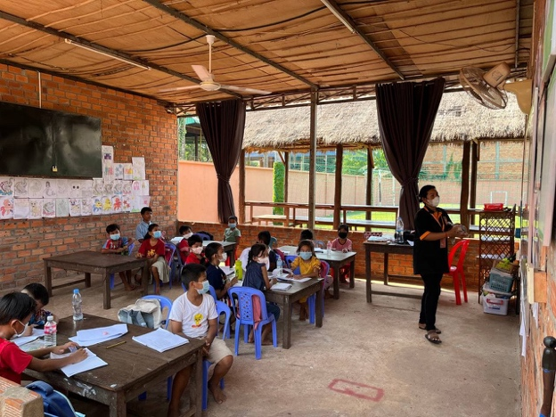Cambodia Children’s Dreams project

The Truckee club has also supported a project in Guatemala sponsored by the Oakland RC. Their global grant enables implementation of key strategies to assist farming families in Guatemala to offset horrific effects of climate change on crops. Recipients are learning crop and poultry management, coffee cultivation, and soil management, to name a few.

The Nevada City 49er Club closed out a multi-year global grant to provide medical equipment to the Centro Medico Clinic at the Filadelfia Hospital in Tijuana, Mexico. Covid made this project a challenge, but the final inspections were completed this year, the grant is closed, and the clinic has replaced outdated equipment with over $200,000.00’s worth of state-of-the-art equipment. Bravo to Dan Bibelheimer and team who organized and completed this worthy project. This club also donated generously to several international service projects – Shelter Box, ICU equipment in the Bwindi Hospital in Uganda, and Casa Hogar Horizonte water and sanitation project in Tijuana.
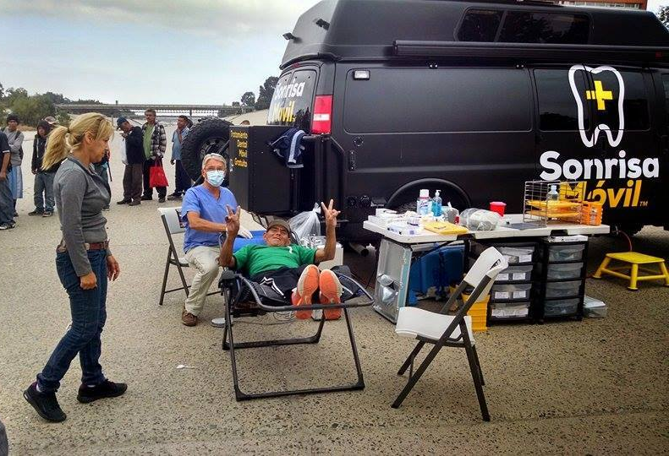

Filadelfia project in Tijuana

The Grass Valley South RC has been active with current projects and ones that have approval but got delayed due to issues related to the COVID pandemic. First is their financial support to the very successful Filadelfia Hospital in Tijuana, Mexico to support the purchase of new and updated equipment. The club has also provided funds to promote the expansion of hospital services and a nursing school program for the Hospital Project in Bwindi, Uganda. The International Service team is applying for a global grant to evacuate Afghanis who assisted the US military and are unable to leave Afghanistan on their own. They have generated over $13,000 in contributions to match their District 5190 grant.

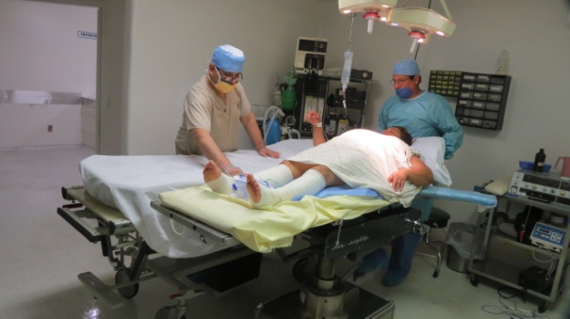

Filadelphia Hospital surgery room

Since summer 2021 the Reno South Rotary Club has been focused on preparing for a global grant in 2022-2023 to provide access to clean water, sanitation and solar power in several departments of Colombia. They are partnering with an NGO, Tierra Grata, and a few clubs in Reno and Carson City. The projects will serve remote rural communities where Tierra Grata has been working for several years -- Atlantico, Magdalena, Cordoba, Bolivar and La Guajira. The club’s International Service chair Masih Madani is leading this project.

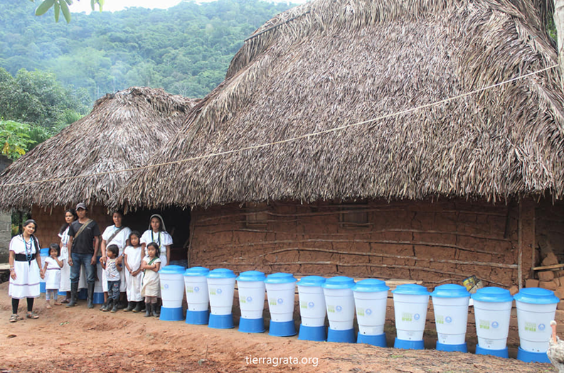
clean water & sanitation project in Colombia

Members of the four Rotary clubs of Auburn -- Auburn Rotary, Gold Country Rotary, Auburn Sunset, and Auburn Passport -- visited the Puerta Hermosa Orphanage and Rancho Genesis youth Camp in Ensenada, Baja, Mexico in 2019. This led to joining forces with the owners to design and implement two projects the make the orphanage and youth camp operate more efficiently and at less cost. They started with a solar system installation with $6000 annual savings that could be put to better use in the orphanage. They received a $10,000 district grant and contributions which have allowed them to have the solar system fully installed by June 2022. In the upcoming Rotary year they will direct their focus on the water treatment system for the youth camp with a global grant to help fund the total cost of approximately $50,000.

.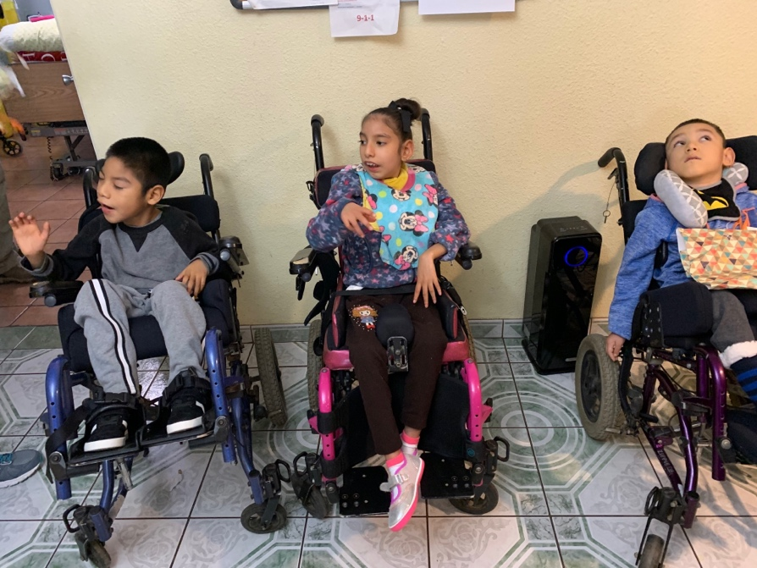

The Passport to Amador Club initiated a project in 2021 to raise funds to provide the resources for women in M’Bale, Uganda to make and distribute menstrual hygiene kits. They are coordinating the project with Mothers in Africa, which is laying the groundwork to begin, such as purchasing sewing machines. Soon, the local women can become entrepreneurs and operate this work as a business, rather than just rely on charity to provide all the supplies, equipment, and training. We wish them much success.
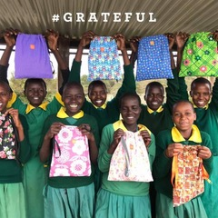

Girls in M’Bale with their hygiene kits

The RC of Nevada City has continued a scholarship through Amigos de Guatemala to a middle-school student, Wendy, so that she can then attend high school and university to become a doctor. The club is also contributing $1300 project for the Centro de Salud, a government health clinic, in Los Barriles, Mexico with its Twin Rotary Club, the Los Barriles Cabo de Este Club. May the Covid restrictions there be lifted in the coming Rotary year so club members can once again participate in person.

The Bishop Sunrise Club is continuing its long-term work to improve women’s and girls’ maternal health services in rural Chiapas, Mexico. But the implementation of the project has been difficult these past two years due to the pandemic, which has been particularly devastating to communities such as Chiapas. The Global Grant Vocational Training Team is returning to Chiapas, Mexico in May to resume the “Trainer the Trainer Maternal Health Team Building Obstetrical Emergency “training. The club will also resume the Menstrual Hygiene kits project.

